**Installing Keyestudio NANO CH340 Driver**

If your computer is not Windows 10, but other Windows systems, you need to manually select the driver file to install the driver. Let's take another Windows system (other than Windows 10) as an example: (you need to use the driver "**[usb_ch341_3.1.2009.06](https://drive.google.com/open?id=1ssALY3RCks_VnWJJ-TuBczs28s2gimEI)**" we provide here)

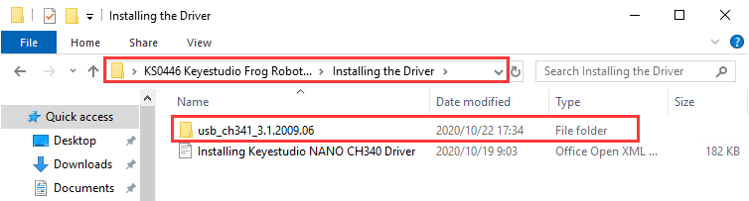

The USB to serial port chip of this control board is CH340G. So you need to install the driver for the chip. You can click the driver file here **[usb_ch341_3.1.2009.06](https://drive.google.com/open?id=1ssALY3RCks_VnWJJ-TuBczs28s2gimEI)** to download it.  
In different systems, the driver installation is similar. Here we start to install the driver on the Win7 system.  
Plug one end of your USB cable into the Keyestudio NANO ch340 board and the other into a USB socket on your computer.   
When you connect the NANO ch340 board to your computer at the first time, right click your “Computer” —>for “Properties”—> click the “Device manager”, under Other devices, you should see the

“USB2.0-Serial”.

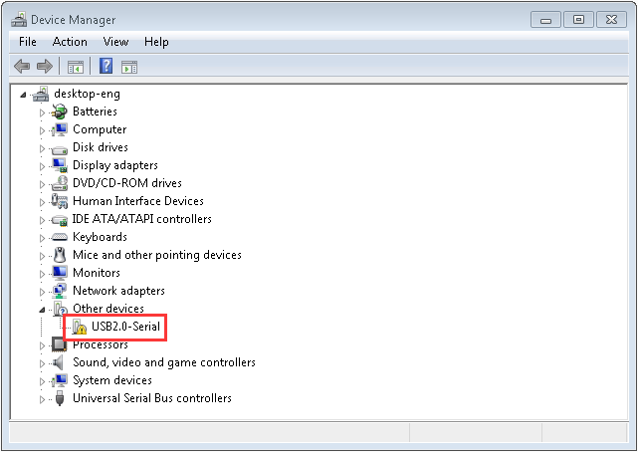

Then right-click on the USB2.0-Serial and select the top menu option (Update Driver) shown as the figure below.

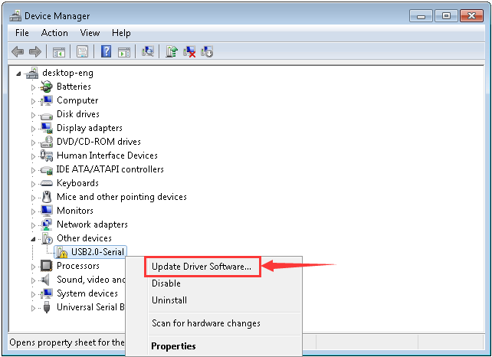

Then it will be prompted to either “Search automatically for driver ” or “Browse my computer for drivers”. Shown as below. In this page, select “Browse my computer for drivers”.

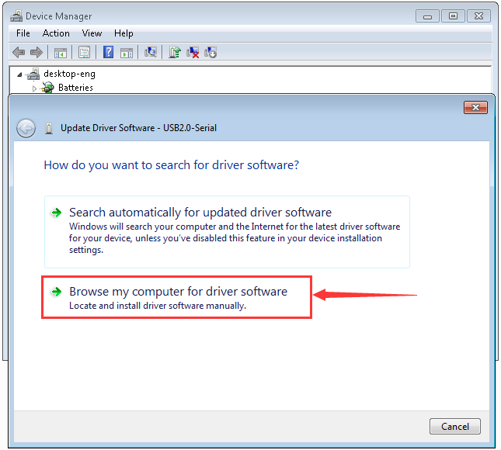

After that, select the option to browse and navigate to the “installing the Driver” folder of **usb_ch341_3.1.2009.06** installation.

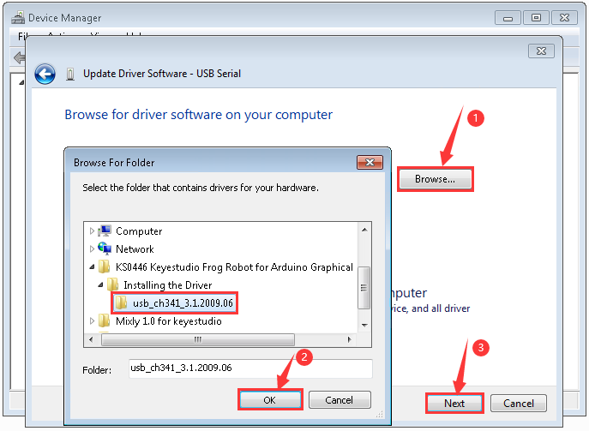

Once the software has been installed, you will get a confirmation message. Installation completed, click “Close”.

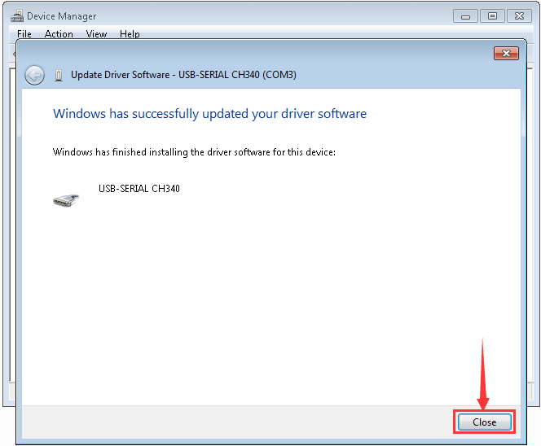

Up to now, the driver is installed well. Then you can right click

“Computer” —>“Properties”—>“Device manager”, you should see the device as the figure shown below.

